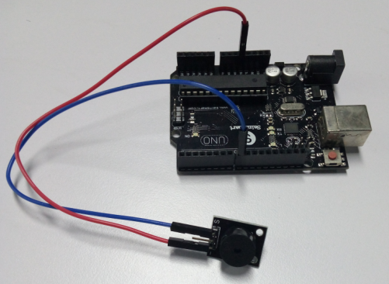

Arduino can be done with a lot of interactive work, the most common and most commonly used is the sound and light show in front has been LED lights are used in the experiments, we let the experiment circuit sound, a voice of the most common.

Component is the buzzer and speaker, and comparison of the two buzzer easier and ease the

present study, we buzzer.

Buzzer and the principle

(A) the introduction of the buzzer

1. Buzzer Buzzer is an integrated role in the structure of electronic transducers, DC voltage power

supply, wide

Pan used in computers, printers, copiers, alarms, electronic toys, automotive electronic equipment,

telephones, timers, etc.

Electronic products for sound devices.

2. The classification is divided into buzzer piezo buzzer buzzer and two types of electromagnetic

buzzer.

3. Graphic symbols buzzer buzzer circuit in the circuit by the letter "H" or "HA" (old standard

with

"FM", "LB", "JD", etc.) indicates.

(Two) structural principle buzzer

1. Piezo Buzzer Piezo Buzzer mainly by the multivibrator, piezo buzzer, impedance matching and

resonance

Boxes, housing and other components. Some piezo buzzer case is also equipped with light-

emitting diodes.

Multivibrator constituted by the transistors or integrated circuits. When switched on (1.5 ~ 15V

DC working voltage), multi-

Harmonic oscillator start-up, the output 1.5 ~ 2.5kHZ audio signals, impedance matching push

piezo buzzer sound.

Piezo buzzer by a lead zirconate titanate or lead magnesium niobate piezoelectric ceramic

material. Both sides of the ceramic piece plated silver electrode

The polarization and the aging process, and then with brass or stainless steel sheet stick together.

2. Magnetic Buzzer Magnetic Buzzer by the oscillator, the electromagnetic coil, magnet,

diaphragm and housing and other components.

After power on, the audio signal generated by the oscillator current through the electromagnetic

coil, the electromagnetic coil generates a magnetic field. Shake

Moving the diaphragm in the electromagnetic coil and magnet interaction, periodically sound

vibration.

Active and passive buzzer buzzer What is the difference

Here the "source" does not mean power. But rather refers to the shock source. In other words, the

active internal buzzer with shock source, so only

Will be called to an energized.

The passive internal sources without shocks, so if a DC signal can not make it tweet. Must 2K ~

5K square wave to

Drive it.

Buzzer often than passive expensive, because there multiple oscillator circuit.

Passive buzzer advantages are: 1. Cheap, 2. Sound frequency control, you can make a "more than

a meter hair Suola Xi 'efficiency

Fruit. 3. In some special cases, you can reuse a control and LED port active buzzer advantages are:

process control

Convenient.

ARDUINO refer to the source:

int buzzer=8;

void setup()

{

pinMode(buzzer,OUTPUT);

}

void loop()

{

unsigned char i,j;

while(1)

{

for(i=0;i<80;i++)

{

digitalWrite(buzzer,HIGH);

delay(1);

digitalWrite(buzzer,LOW);

delay(1);//ms

}

for(i=0;i<500;i++)

{

digitalWrite(buzzer,HIGH);

delay(2);

digitalWrite(buzzer,LOW);

delay(2);

}

}

}